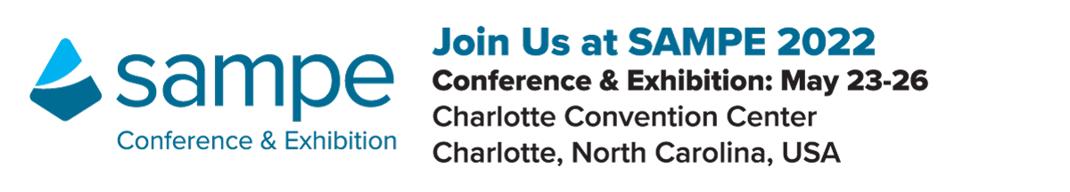
Customize this letter/email to appropriately fit your needs. Suggest pasting it onto your company letterhead before sending, or send as a regular email.

Request to Attend the SAMPE 2022 Conference and Exhibition
Dear [insert supervisor name],
I am requesting your approval to attend the SAMPE 2022 Conference and Exhibition taking place May 23 – 26th at the Charlotte Convention Center, Charlotte, North Carolina.
Why should I attend SAMPE 2022?
- SAMPE 2022 is the only technical conference and exhibition exclusively dedicated to advanced materials and processes.
- This will give me an opportunity to directly engage with domestic and international buyers, manufacturers and suppliers - spanning the Aerospace/Aircraft, Automotive, Marine, Energy and many other industries, beyond what I am able to accomplish online.
- Industry experts will be presenting technology challenges and solutions they have uncovered – what better way to advance my knowledge and move forward in meeting our organization’s project goals than learning solutions first hand.
- With over 160 technical presentations offered, and the opportunity to meet with over 200 exhibiting companies, potential solutions are possible.
SAMPE provides a great blend of education, innovations, technology solutions, and networking opportunities for everyone. Not only will I learn new things, I’ll grow my network, and meet with experts that can provide solutions and expertise that I can use throughout my career.
Below is the approximate cost of attending for your review:
Registration:* $ (Rates increase April 23)*
Airfare: $
Hotel: $
Meals: $
Total: $
I think you’ll agree that this is a small investment when we consider the value I will bring back. Thank you for your consideration and support of my professional development – I look forward to hearing from you!
Best Regards,
[insert your name]

