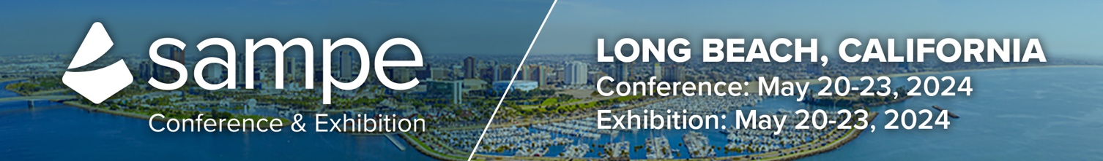
Customize this letter/email to appropriately fit your needs. Suggest pasting it onto your company letterhead before sending it or send as a regular email.

Request to Attend the SAMPE 2024 Conference and Exhibition
Dear [insert supervisor name],
I am requesting your approval to attend the SAMPE 2024 Conference and Exhibition taking place May 20 – 23, 2024, at the Long Beach Convention Center, in Long Beach, California.
Why should I attend SAMPE 2024?
- SAMPE 2024 is the only technical conference and exhibition exclusively dedicated to advanced materials and processes.
- This will allow me to directly engage with domestic and international buyers, manufacturers, and suppliers - spanning the Aerospace/Aircraft, Automotive, Marine, Energy, and many other industries, beyond what I can accomplish online.
- Industry experts will be presenting technology challenges and solutions they have uncovered – what better way to advance my knowledge and move forward in meeting our organization’s project goals than learning solutions firsthand.
- With over 125 technical presentations offered and the opportunity to meet with over 200 exhibiting companies, potential solutions are possible.
SAMPE provides everyone with a great blend of education, innovations, technology solutions, and networking opportunities. Not only will I learn new things, but I’ll also grow my network and meet with experts that can provide solutions and expertise that I can use throughout my career.
Below is the approximate cost of attending for your review:
Registration: * $75-$1,350 (Rates increase September 16)
Attendee passes with exhibit hall access are $75
Airfare: $
Hotel: $
Meals: $
Total: $
I think you’ll agree that this is a small investment when we consider the value I will bring back. Again, thank you for your consideration and support of my professional development – I look forward to hearing from you!
Best Regards,
[insert your name]

